Chapter 4, Solution 36.

Solve for the current i in the circuit of Fig. 4.103 using Thevenin’s theorem. (Hint: Find the Thevenin equivalent as seen by the 12-Ω resistor.)

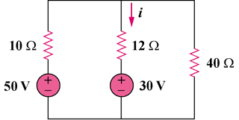

Figure 4.103
For Prob. 4.36.

Solution

Remove the 30-V voltage source and the 20-ohm resistor.

(a)

10Ω

R_{Th}

40Ω

b

a

50V

+
−

V_{Th}
+

(b)

10Ω

40Ω

b

a

From Fig. (a), R_{Th} = 10||40 = 8 ohms

From Fig. (b), V_{Th} = (40/(10 + 40))50 = 40V

40V

+
−

i

(c)

12 Ω

b

a

30V

+
−

8 Ω

The equivalent circuit of the original circuit is shown in Fig. (c). Applying KVL,

30 – 40 + (8 + 12)i = 0, which leads to i = 500mA

